Who's Who
These are the people who make up the Governing Body of Broomhill Infant School.
For more information, or to contact a Governor contact the school office.

 | Robin Millard  Chair of Governors  Safeguarding Governor  CIC/LAC Governor  Maths Lead Governor  Classification: Co-opted Governor  Appointed: 07 DEC 2020  Term ends: 06 DEC 2028
 | Sapna Boden  SEND & PP Governor  Classification: Co-Opted Governor  Appointed: 20 OCT 2020  Term ends: 19 OCT 2028
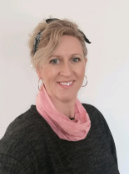 | Lydia Collins  Health and Safety and Premises Governor  Classification: Co-Opted Governor  Appointed: 20 OCT 2020  Term ends: 19 OCT 2028
 | Hayley Farthing  Classification: Head Teacher  Appointed: 11 APR 2016  Term ends: n/a
 | Fran Cousins  Classification: Staff Governor  Appointed: 10 DEC 2024  Term ends: 09 DEC 2028
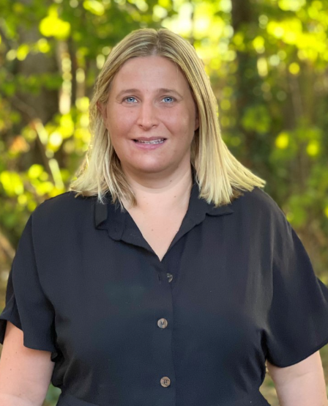 | Victoria Nicholls  Deputy Head  Classification: Associate Governor  Appointed: 01 SEP 2022  Term ends: 31 AUG 2026
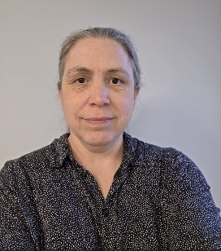 | Louise Gutierrez Phillips  Wellbeing Governor  Classification: Co-opted Governor  Appointed: 07 NOV 2023  Term ends: 06 NOV 2027
 | Katya Hornchen  STEM Link Governor  Classification: Co-opted Governor  Appointed: 07 FEB 2022  Term ends: 06 FEB 2030
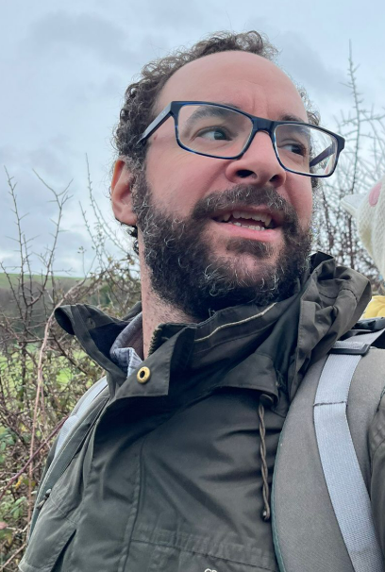 | Daniel Colegate  Reading, Writing & Literacy Lead Governor  Classification: Parent Governor  Appointed: 21 OCT 2025  Term ends: 20 OCT 2029
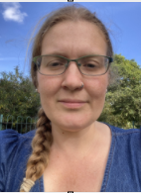 | Nadia Kevlin  Wider Curriculum Lead Governor  Classification: Parent Governor  Appointed: 22 SEP 2026  Term ends: 21 SEP 2030
Vacancy | Co-opted
Vacancy | Co-opted
Vacancy | Co-opted
Vacancy | Foundation
Vacancy | Foundation
Vacancy | LA Governor

